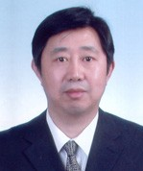**Professor Liang Xu**

Director of Beijing Institute of Ophthalmology and Vice Director of Beijing Tongren Hospital.

Prof. Xu is a research leader of screening for glaucoma, early diagnosis, epidemiological studies of eye diseases and the model of blindness prevention. He has published over 50 research papers in international journals and conferences proceedings in the last 5 years.

Currently, he is a member of the standing committee of the Chinese Ophthalmologic Society and editor-in-chief of the Ophthalmology Journal and Foreign Medical Science.

He was honoured as an expert with outstanding contributions by Beijing City and received the outstanding prize of prevention of blindness by Asia-Pacific Association of Ophthalmology.

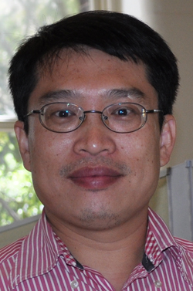**Associate Professor Jinyan Li**

Associate Professor Li specialises in bioinformatics, computational biology, data mining, graph theory, information theory, machine learning and theoretical biology. He has published 70 journal articles and 65 conference papers of which many are highly cited.

He is known for his theoretical research work on emerging patterns that has produced numerous follow-up research interests in data mining, machine learning, and bioinformatics.

<http://www.uts.edu.au/staff/jinyan.li>

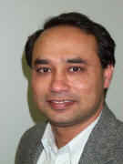**Professor Rezaul Begg**

Professor Begg's main fields of research include; biomechanics, biomedical engineering and machine learning. He has published 50 journal articles, 1 research book, 4 edited books, 15 book chapters, 85 refereed full conference papers, 27 conference abstracts and 3 reports.

His work focuses on developing new technologies and techniques with applications to human gait pathologies.

He is a senior member of the IEEE professional society, IEEE Engineering in Medicine and Biology Society (EMBS), and IEEE Computational Intelligence Society (CIS).

<http://www.vu.edu.au/contact-us/rezaul-begg>